{{TODAY_LONG}}

SENT VIA FASCIMILE
{{insurance2.insurer.name}}
Claim No.: {{insurance2.claimnumber}}
Attn: {{insurance2.adjuster.name}}
{{insurance2.adjuster.address1line1}} {{insurance2.adjuster.address1line2}}
{{insurance2.adjuster.address1city}}, {{insurance2.adjuster.address1state}} {{insurance2.adjuster.address1zip}}
F: {{insurance2.adjuster.fax1}}
E: {{insurance2.adjuster.email1}}

RE: Our Client(s): {{fullname}} and _______

Your Insured: {{insurance2.insured.name}}
Date of Accident: {{intake.incidentDate}}
Claim Number: {{insurance2.claimnumber}}
Policy Number: {{insurance2.policynumber}}

Dear Mr./Ms. {{insurance2.adjuster.lastname}},

Pursuant to Smith v. Safeco Ins., 150 Wn.2d 478, 78 P.3d 1274 (2003), you have a duty to disclose where disclosure is in the insured’s best interest. As the damages in this matter foreseeably exceed Washington’s minimal liability limits, we request that you disclose your insured’s policy limits including that of any other possible coverage. Let this letter serve as our formal request of said limits and put you on notice that response must be received within 10 days.

Should you have any further questions, comments or concerns regarding the contents of this letter, or should you require further information, please do not hesitate to contact our office.
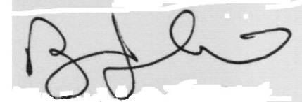


Very Truly Yours,

Andrew Stikovac, ESQ.
Gold Medal Injury Law
AS/______

